Persistence service:
It is used for storing the state of object (CURRENT values of the object) permanently in the database.
By default, the life time of the object is local to the program i.e. once a program execution is completed, memory allocated for the object will be destroyed by the garbage collector.
Persistence object means -> permanent object
Any database operation (CRUD operations) can be achieved by using “persistent service”.
Persistence service is implemented by creating persistence classes.
Persistence class is always created globally (class builder).
The naming standard of persistent class is ‘ZCL_<classname> ‘ / ’YCL_<classname>’.
Persistence class is always created as protected class.
Whenever a persistence class is created, SAP creates two more classes internally.
- Base agent class: (abstract class) i.e. ‘ZCB_<class name>’.
- Actor /agent class: (Private class) i.e. “ZCA_<class name>”.
Base agent class: is a friend of persistence class and it is super class of ACTOR / AGENT class.
Actor class: is a subclass of Base agent class
By Default, Persistence class implements a standard interface ‘IF_OS_STATE’ which is responsible for storing the state of the object permanently in the database.

Persistence service can be implemented in two ways:
1. Business key identity.
2. GUID (Global Unique Identifier).
Persistence service using business key identity:
- In this, we need to consider a database table in which the primary key field/s of the table is considered as “Business key identity”.
- This field is used for uniquely identifying the object.
Procedure for using persistence service using Business key
- Consider a db table
Table: z1130emp
Fields:
Empno (PK) zempno int4 10
Ename zename char 20
Empdesig zempdesig char 20
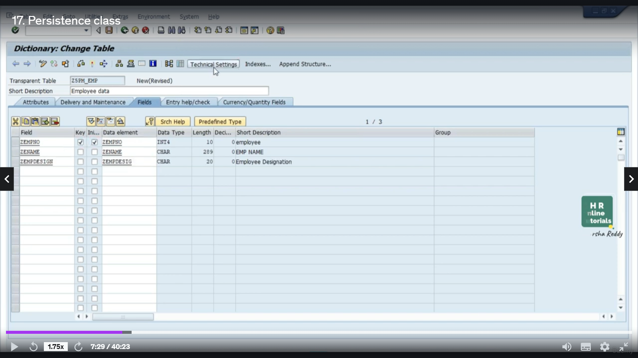
- Create the persistence class.
Persistence class: zcl_1130_persistence_key
Base agent class: zcb_1130_persistence_key
Actor/agent class: zca_1130_persistence_key
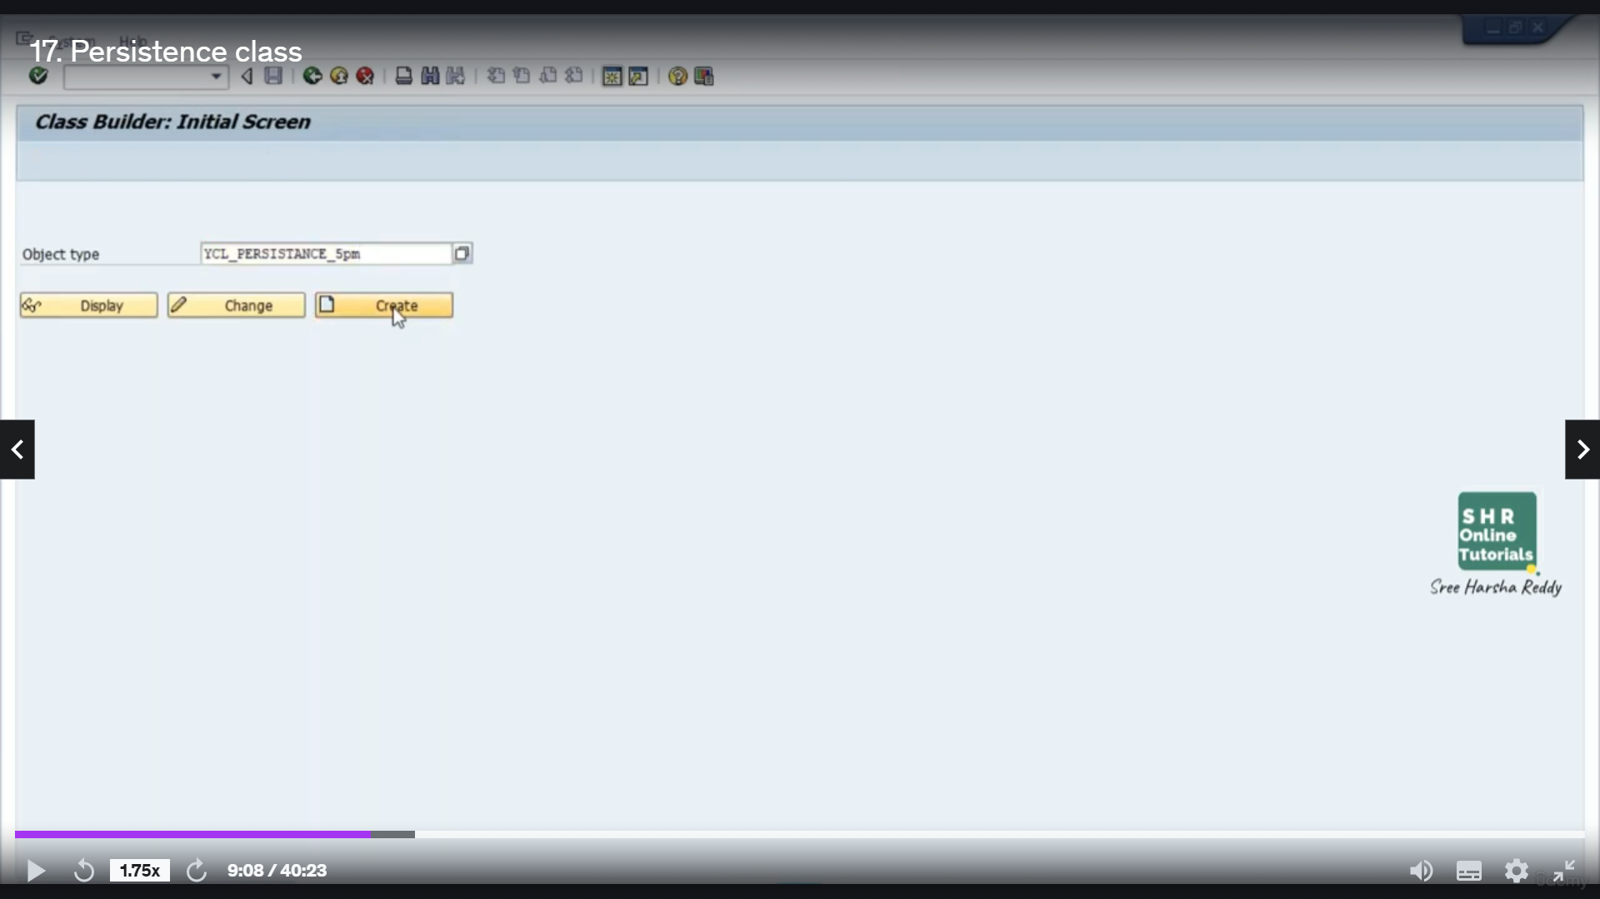
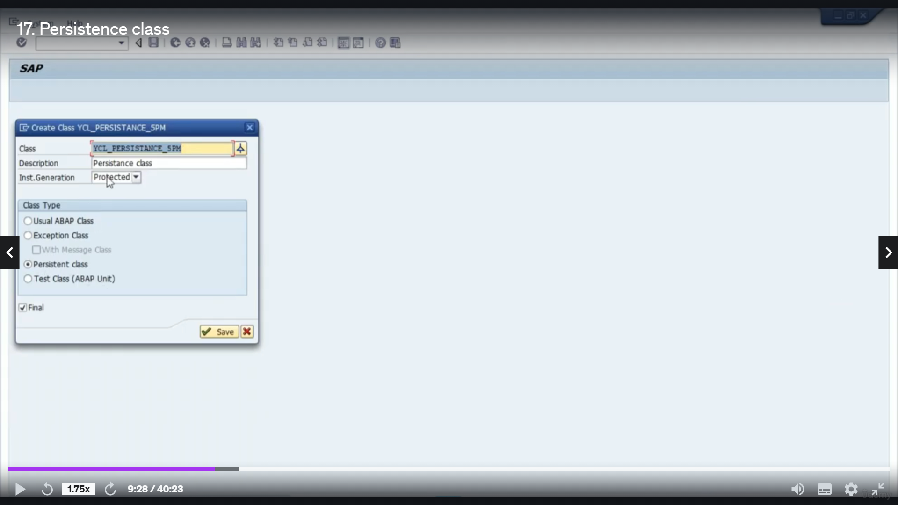
Note: By default, Persistence class implements the interface ‘if_os_state’ which is responsible for storing the state of the object permanently.
- Map the Persistence class with the Corresponding data base table. (‘goto’ menu→ persistence representation)
Note: We must map all the fields of the db table to the persistence class (double click on each field and click on ‘set attribute values’ button)
Note: Once the mapping is done, all the fields of the table will be added as attributes of the persistence class.
- Apart from this, SAP GENERATES “GET_” Methods for all attributes and “SET_” methods for non-primary key fields.
- Getter method is used for reading the value of the attribute and Setter method is used for setting the value to the attribute.
- Activate the persistence class so that dependent classes also get activated.
- As part of this activation, SAP generates the following methods as part of base agent class.
- Create _Persistent
- Delete_Persistent.
- Get_Persistent
To interact with the Persistent object we need to access above 3 methods:
- To access the above 3 instance Methods we require object of base agent class, but the base agent class is created as “Abstract class”. So, it cannot be instantiated directly.
- The above 3 methods are public and they are inherited to sub class which is Actor Class or Agent class.
- But, Actor class IS created as “Private Class”, so, it cannot be instantiated directly outside.
- Actor class is created as Singleton class, so there is a possibility of creating one and only one object. So in order to get the object of the Actor class we must follow the following Procedure.
- As part of every Actor class, SAP Provides Static Public Attribute “Agent”. This attribute is marked as ‘Read only’ i.e this attribute will return a value whenever it is accessed.
- Whenever this attribute is accessed by using Actor class name , internally SAP Executes Static Constructor of Actor class which is Responsible for creating singleton (single object) of actor class, This object will be returned back to the static attribute agent, we need to receive this returned object so that we can access the above 3 methods.
- “COMMIT WORK” statement will save changes permanently in the database.
Persistence Service Using GUID (global unique identifier):
- In this we need to consider a database table whose first field is GUID and the corresponding data element should be “OS_GUID”. The value for this field “GUID” will be dynamically generated by SAP itself.
- We need to map the persistence class with this database table. After Mapping, except “GUID” field all the remaining fields will be added as attributes of the class.
- Apart from this, SAP Generates “Getter” &”Setter” methods as part of persistence class for all the fields except “GUID”.
- When we activate the persistence class, SAP generates the following 3 Methods as part of “BASE AGENT CLASS”.
- Create_Persistent.
- IF_OS_CA_PERSISTENCY~GET_PERSISTENT_BY_OID
- IF_OS_FACTORY~DELETE_PERSISTENT.

Procedure for creating Persistence service using GUID:
Step1: Consider a database table with GUID as first field.
Table: y745emp
Fields: Data element
GUID os_guid (Primary Key)
EMPNO zeMPno
ENAME zename
EMPDESIG zempdesig
Step 2: create the persistence class( ycl_815emp)
Base agent class à ycb_815emp
Actor classà yca_815emp
Step 3: Map the persistence class with the above table.
In persistence service using GUID the uniqueness of the object is controlled based on the GUID field.
GET_PERSISTENT_BY_OID:
This method takes GUID as input and returns the object of the object class. This object class in the runtime points to persistence class, so we need to type cast the object class object to persistence class object. Using the persistence class object access the required getter methods.
DELETE_PERSISTENT:
This method takes the object of the interface ‘if_os_state’ as input value, but we cannot directly create objects for interfaces, so we need to analyze what is the implementation class which is implementing this particular interface. As per the analysis, it is the persistence class (ycl_emp) which is implementing the interface ‘if_os_state’, so we can pass the object of this persistence class as a parameter value. In order to get the object of persistence class, first of all we have to check whether the “GUID” is existing or not this is done by calling the instance method “Get_Persistence_By_Oid” .This method returns object of the object class, this object class object needs to be type cast to persistence class object and pass that object as parameter to “Delete_Persistent”.

